**Model Validation In ASP.NET MVC Core 3.1**

In this article we will understand the concept of model validation in ASP.NET MVC core 3.1. It is valid for any version of MVC core. These validations are available in System.ComponentModel.DataAnnotations namespace. Validation attributes let us specify validation rules for model properties. Model state represents errors that come from two sub systems' model binding and model validation.

There are in-built attributes in ASP.NET MVC core,

|  |  |
| --- | --- |
| Attribute | Description |
| CreditCard | This validates that the property has a credit card format. |
| Compare | This attribute validates that two property in model class match like password and compare password. |
| EmailAddress | This validates the property has email address format. |
| Phone | This validates that the property has a telephone number format. |
| Range | This validates that the property value within a specified range. |
| RegularExpression | This validates that the property value matches a specified regular expression. |
| Required | This validates that the field is not null |
| StringLength | This validates that a string property value doesn't exceed a specified length limit. |
| Url | This validates that the property has a URL format. |
| Remote | This validates input on the client by calling an action method on the server |

**Step 1**

Start-up Visual Studio 2019. Now click on create new project and Choose ASP.NET Core Web Application and click on “Next”

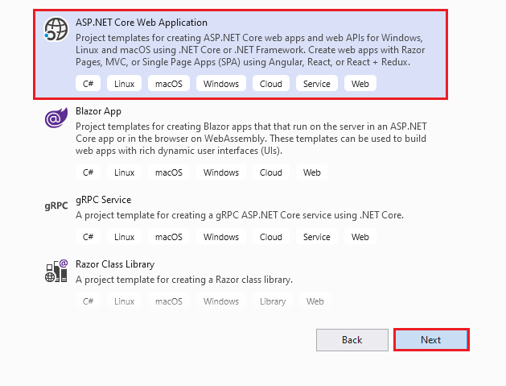

After clicking next, another wizard will open. Under the project name, give a meaningful name to your project and click on create.

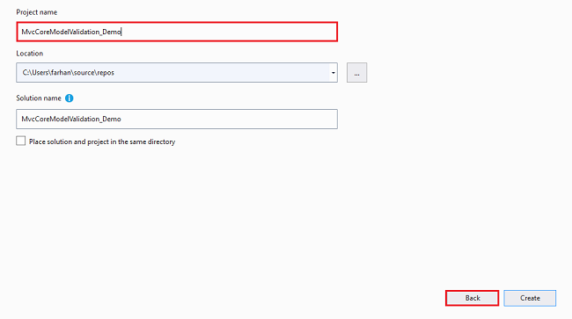

That will open up another new wizard. Select ASP.Net Core 3.0 from the dropdown. If not, select default. Choose Web Application (Model-View-Controller) template and click on create which will create ASP.Net Core Application.

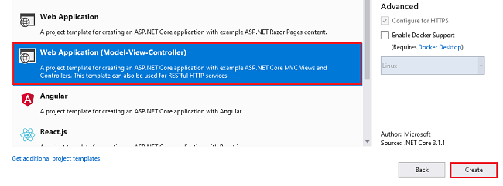

**Step 2**

Now right click on Models folder and “Add” class and name it Student.

**using** System;

**using** System.ComponentModel.DataAnnotations;

**namespace** MvcCoreModelValidation_Demo.Models

{

**public** **class** Student

    {

        [Key]

**public** **int** Id { **get**; **set**; }

        [Required(ErrorMessage = "Please enter name")]

        [StringLength(100)]

**public** **string** Name { **get**; **set**; }

        [Required(ErrorMessage = "Please choose gender")]

**public** **string** Gender { **get**; **set**; }

        [Required(ErrorMessage = "Please enter date of birth")]

        [Display(Name = "Date of Birth")]

        [DataType(DataType.Date)]

**public** DateTime DateofBirth { **get**; **set**; }

        [Required(ErrorMessage = "Choose batch time")]

        [Display(Name = "Batch Time")]

        [DataType(DataType.Time)]

**public** DateTime BatchTime { **get**; **set**; }

        [Required(ErrorMessage = "Please enter phone number")]

        [Display(Name = "Phone Number")]

        [Phone]

**public** **string** PhoneNumber { **get**; **set**; }

        [Required(ErrorMessage = "Please enter email address")]

        [Display(Name = "Email Address")]

        [EmailAddress]

**public** **string** Email { **get**; **set**; }

        [Required(ErrorMessage = "Please enter website url")]

        [Display(Name = "Website Url")]

        [Url]

**public** **string** WebSite { **get**; **set**; }

        [Required(ErrorMessage = "Please enter password")]

        [DataType(DataType.Password)]

**public** **string** Password { **get**; **set**; }

        [Required(ErrorMessage = "Please enter confirm password")]

        [Display(Name = "Confirm Password")]

        [Compare("Password", ErrorMessage = "Password and confirm password does not match")]

**public** **string** ConfirmPassword { **get**; **set**; }

    }

}

**Step 3**

Now open HomeController which is added when we created new project. Write the following code for Index and New IActionResult methods.

**using** Microsoft.AspNetCore.Mvc;

**using** MvcCoreModelValidation_Demo.Models;

**namespace** MvcCoreModelValidation_Demo.Controllers

{

**public** **class** HomeController : Controller

    {

**public** IActionResult Index()

        {

**return** View();

        }

        [HttpPost]

        [ValidateAntiForgeryToken]

**public** IActionResult Index(Student student)

        {

**if** (ModelState.IsValid)

            {

            }

**return** View();

        }

    }

}

**Step 4**

Right click on Index IActionResult method. “Add” view with default name “Index” if you don’t have it. Write the following code.

@model MvcCoreModelValidation_Demo.Models.Student

@{

    ViewData["Title"] = "Home Page";

}

<div **class**="card">

    <div **class**="card-header bg-primary text-white text-uppercase">

        <h4>Student Information</h4>

    </div>

    <div **class**="card-body">

        <form asp-action="Index">

            <div **class**="row">

                <div **class**="col-md-6">

                    <div **class**="form-group">

                        <label asp-**for**="Name" **class**="lable-control"></label>

                        <input asp-**for**="Name" **class**="form-control" />

                        <span asp-validation-**for**="Name" **class**="text-danger"></span>

                    </div>

                </div>

                <div **class**="col-md-6">

                    <div **class**="form-group">

                        <label asp-**for**="Gender" **class**="lable-control"></label>

                        <select **class**="custom-select">

                            <option value="">Choose Gender</option>

                            <option value="Male">Male</option>

                            <option value="Female">Female</option>

                        </select>

                        <span asp-validation-**for**="Gender" **class**="text-danger"></span>

                    </div>

                </div>

            </div>

            <div **class**="row">

                <div **class**="col-md-6">

                    <div **class**="form-group">

                        <label asp-**for**="DateofBirth" **class**="lable-control"></label>

                        <input asp-**for**="DateofBirth" **class**="form-control" />

                        <span asp-validation-**for**="DateofBirth" **class**="text-danger"></span>

                    </div>

                </div>

                <div **class**="col-md-6">

                    <div **class**="form-group">

                        <label asp-**for**="BatchTime" **class**="lable-control"></label>

                        <input asp-**for**="BatchTime" **class**="form-control" />

                        <span asp-validation-**for**="BatchTime" **class**="text-danger"></span>

                    </div>

                </div>

            </div>

            <div **class**="row">

                <div **class**="col-md-4">

                    <div **class**="form-group">

                        <label asp-**for**="PhoneNumber" **class**="lable-control"></label>

                        <input asp-**for**="PhoneNumber" **class**="form-control" />

                        <span asp-validation-**for**="PhoneNumber" **class**="text-danger"></span>

                    </div>

                </div>

                <div **class**="col-md-4">

                    <div **class**="form-group">

                        <label asp-**for**="Email" **class**="lable-control"></label>

                        <input asp-**for**="Email" **class**="form-control" />

                        <span asp-validation-**for**="Email" **class**="text-danger"></span>

                    </div>

                </div>

                <div **class**="col-md-4">

                    <div **class**="form-group">

                        <label asp-**for**="WebSite" **class**="lable-control"></label>

                        <input asp-**for**="WebSite" **class**="form-control" />

                        <span asp-validation-**for**="WebSite" **class**="text-danger"></span>

                    </div>

                </div>

            </div>

            <div **class**="row">

                <div **class**="col-md-6">

                    <div **class**="form-group">

                        <label asp-**for**="Password" **class**="lable-control"></label>

                        <input asp-**for**="Password" **class**="form-control" />

                        <span asp-validation-**for**="Password" **class**="text-danger"></span>

                    </div>

                </div>

                <div **class**="col-md-6">

                    <div **class**="form-group">

                        <label asp-**for**="ConfirmPassword" **class**="lable-control"></label>

                        <input asp-**for**="ConfirmPassword" **class**="form-control" />

                        <span asp-validation-**for**="ConfirmPassword" **class**="text-danger"></span>

                    </div>

                </div>

            </div>

            <div **class**="form-group">

                <button type="submit" **class**="btn btn-primary rounded-0">Submit</button>

            </div>

        </form>

    </div>

</div>

**Step 5**

Build and run your application by pressing ctrl+F5

